https://www.codementor.io/blog/5-essential-reactjs-interview-questions-du1084ym1

My experience has taught me that the best candidates for an engineering role are those who can articulate intelligent opinions and defend them using examples from their own experience.

What is React?
React is an open-source JavaScript library created by Facebook for building complex, interactive UIs in web and mobile applications.

The key point in this answer is that React’s core purpose is to build UI components; it is often referred to as just the “V” (View) in an “MVC” architecture.

React vs Angular 2: Comparison scope
=====================================
1. The concepts
----------------
Let's begin with the basics...

A. Angular2
Watchers: Watchers are attached to each component and each time a component is changed, watchers check if we should modify something else; and if needed, make appropriate modifications. The Angular 2 team did a great job to make that part way faster than its previous version. So from now on, each time a component is changed, we don’t have to run any verifications on objects (depending on immutable elements).

There is another striking point in using Angular 2: it requires TypeScript. But we will talk about this again…

B. React
Facebook’s baby is more like a UI component render than a full framework. The big thing (that everyone is talking about) is the virtual DOM. This is a killer feature which is giving React three main advantages:

The changes occur by comparison between the DOM and the virtual DOM only, so React will only change what’s needed in the most optimal way.
We don’t really need a browser to test React as we don’t interact directly with the DOM.
We can connect the Virtual DOM to another entity (look at the mobile developments made in native code or Electron)
Components created in React have a state (representing the component-related data) and updating this state will allow your page to be reactive.

Imagine creating a “counter” component — the thing that you will likely want to change is the value of that counter, it will then be the state of our counter component.
E. Speed
----------------
Before talking about performances, we should talk a little about how the two handle binding. On one side, Angular 2 uses two-way data binding. This means that if I decide to change the value in the DOM, say an input field or a text area, both the view and the model will be updated. This behavior is made possible by a lot of observers. Each binding requires a watcher; so the bigger your app is getting, the bigger the impact of those watchers is also going to be.

On the other side with React, we have to write the code that handles tracking the changes between view and models. But once it is done (and even though you might feel that implementing something like Flux is going to slow down your app), the components stay very fast as we only change the elements that are changed in the DOM (thanks to the virtual DOM of React, only the virtual DOM elements that have difference with the actual DOM elements are updated). The result is that updates are made in a smoother way.

To make it a bit more precise, please check this link, as you will get true benchmarks on the performances of both Angular 2 and React (among others, which is always good to see)

Webpack
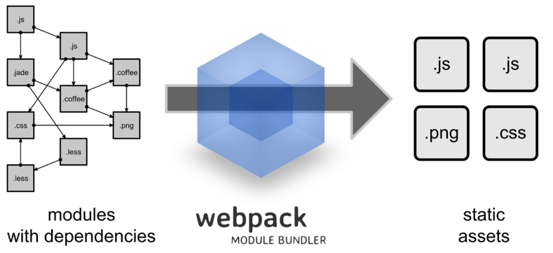
Webpack - you turn a bunch of small files with a lot of relationships and connections into bigger, “reunited” files. The main point is that it can be interpreted then by the browsers, even when minified. With such tools, you will be able to bundle all react components to make sure all the dependencies are resolved.
Module bundlers are just what they are called, they bundle up JavaScript modules into one file. This way, when the client makes a request to your server, it doesn’t have to make multiple requests for static files. Instead, one file is requested, which in some cases, includes your JavaScript bundle and CSS style. This helps optimize load time and makes you more in control as you can choose to include only what you need when you need it.

Question #2: What happens during the lifecycle of a React component?
One of the most valuable parts of React is its component lifecycle — so understanding exactly how components function over time is instrumental in building a maintainable application.

High-Level Component Lifecycle
At the highest level, React components have lifecycle events that fall into three general categories:
- Initialization
- State/Property Updates
- Destruction
Every React component defines these events as a mechanism for managing its properties, state, and rendered output. Some of these events only happen once, others happen more frequently; understanding these three general categories should help you clearly visualize when certain logic needs to be applied.
For example, a component may need to add event listeners to the DOM when it first mounts. However, it should probably remove those event listeners when the component unmounts from the DOM so that irrelevant processing does not occur.
class MyComponent extends React.Component {
// when the component is added to the DOM...
componentDidMount() {
window.addEventListener('resize', this.onResizeHandler);
}

// when the component is removed from the DOM...
componentWillUnmount() {
window.removeEventListener('resize', this.onResizeHandler);
}

onResizeHandler() {
console.log('The window has been resized!');
}
}

Low-Level Component Lifecycle
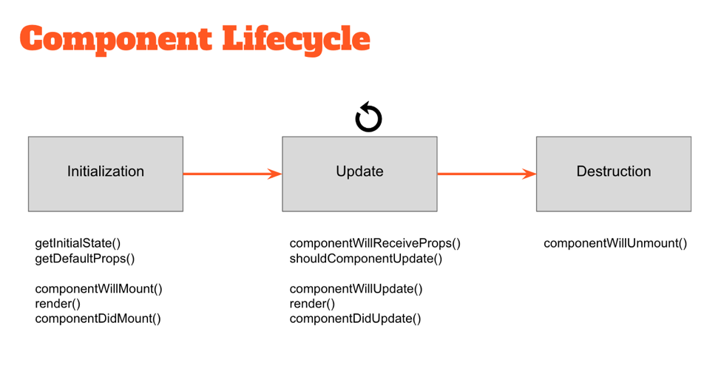
Within these three general buckets exist a number of specific lifecycle hooks — essentially abstract methods — that can be utilized by any React component to more accurately manage updates. Understanding how and when these hooks fire is key to building stable components and will enable you to control the rendering process (improving performance).
Take a look at the diagram above. The events under “Initialization” only happen when a component is first initialized or added to the DOM. Similarly, the events under “Destruction” only happen once (when the component is removed from the DOM). However, the events under “Update” happen every time the properties or state of the component change.
For example, components will automatically re-render themselves any time their properties or state change. However, in some cases a component might not need to update — so preventing the component from re-rendering might improve the performance of our application.
class MyComponent extends React.Component {
// only re-render if the ID has changed!
shouldComponentUpdate(nextProps, nextState) {
return nextProps.id === this.props.id;
}
}

Question #3: What can you tell me about JSX?
JSX is a shorthand for JavaScript XML. When Facebook first released React to the world, they also introduced a new dialect of JavaScript called JSX that embeds raw HTML templates inside JavaScript code. JSX code by itself cannot be read by the browser; it must be transpiled into traditional JavaScript using tools like Babel and webpack.
But while ES2015 is becoming more and more widespread, it still is far from widely supported by the major browsers — so tools like Babel or webpack are needed to convert everything into legacy ES5 code.

Question #4: Are you familiar with Flux?
Flux is an architectural pattern that enforces unidirectional data flow — its core purpose is to control derived data so that multiple components can interact with that data without risking pollution.

Description of Flux
In the Flux pattern, the Store is the central authority for all data; any mutations to the data must occur within the store. Changes to the Store data are subsequently broadcast to subscribing Views via events. Views then update themselves based on the new state of received data.
To request changes to any Store data, Actions may be fired. These Actions are controlled by a central Dispatcher; Actions may not occur simultaneously, ensuring that a Store only mutates data once per Action.
The strict unidirectional flow of this Flux pattern enforces data stability, reducing data-related runtime errors throughout an application.

Flux vs MVC
Traditional MVC patterns have worked well for separating the concerns of data (Model), UI (View) and logic (Controller) — but many web developers have discovered limitations with that approach as applications grow in size. Specifically, MVC architectures frequently encounter two main problems:
- Poorly defined data flow: The cascading updates which occur across views often lead to a tangled web of events which is difficult to debug.
- Lack of data integrity: Model data can be mutated from anywhere, yielding unpredictable results across the UI.
With the Flux pattern complex UIs no longer suffer from cascading updates; any given React component will be able to reconstruct its state based on the data provided by the store. The flux pattern also enforces data integrity by restricting direct access to the shared data.
During a technical interview, one should discuss the differences between the Flux and MVC design patterns within the context of a specific example:
For example, imagine we have a “master/detail” UI in which the user can select a record from a list (master view) and edit it using an auto-populated form (detail view).

With an MVC architecture, the data contained within the Model is shared between both the master and detail Views. Each of these views might have its own Controller delegating updates between the Model and the View. At any point the data contained within the Model might be updated — and it’s difficult to know where exactly that change occurred. Did it happen in one of the Views sharing that Model, or in one of the Controllers? Because the Model’s data can be mutated by any actor in the application, the risk of data pollution in complex UIs is greater than we’d like.

With a Flux architecture, the Store data is similarly shared between multiple Views. However this data can’t be directly mutated — all of the requests to update the data must pass through the Action > Dispatcher chain first, eliminating the risk of random data pollution. When updates are made to the data, it’s now much easier to locate the code requesting those changes.

Difference with AngularJS (1.x)
UI components in AngularJS typically rely on some internal $scope to store their data. This data can be directly mutated from within the UI component or anything given access to $scope — a risky situation for any part of the component or greater application which relies on that data.
By contrast, the Flux pattern encourages the use of immutable data. Because the store is the central authority on all data, any mutations to that data must occur within the store. The risk of data pollution is greatly reduced.

Question #5: What are stateless components?
Stateless components (a flavor of “reusable” components) are nothing more than pure functions that render DOM based solely on the properties provided to them.
const StatelessCmp = props => {
return (
<div className="my-stateless-component">
{props.name}: {props.birthday}
</div>
);
};

// ---
ReactDOM.render(
<StatelessCmp name="Art" birthday="10/01/1980" />,
document.getElementById('main')
);
This component has no need for any internal state — let alone a constructor or lifecycle handlers. The output of the component is purely a function of the properties provided to it.
https://www.codementor.io/@nihantanu/21-essential-javascript-tech-interview-practice-questions-answers-du107p62z

21 Essential JavaScript Interview Questions
Published Sep 18, 2015Last updated Dec 08, 2017

1. What is the difference between undefined and not defined in JavaScript?

The assignment happens in order, so when we try to access a variable that is declared but not defined yet, we will get the result undefined.
var x; // Declaration
if(typeof x === 'undefined') // Will return true
If a variable that is neither declared nor defined, when we try to reference such a variable we'd get the result not defined.
> console.log(y); // Output: ReferenceError: y is not defined

What is the drawback of creating true private methods in JavaScript?
One of the drawbacks of creating true private methods in JavaScript is that they are very memory-inefficient, as a new copy of the method would be created for each instance.

What is a “closure” in JavaScript? Provide an example
A closure is a function defined inside another function (called the parent function), and has access to variables that are declared and defined in the parent function scope.
The closure has access to variables in three scopes:
- Variables declared in their own scope
- Variables declared in a parent function scope
- Variables declared in the global namespace
var globalVar = "abc";

// Parent self invoking function
(function outerFunction (outerArg) { // begin of scope outerFunction
// Variable declared in outerFunction function scope
var outerFuncVar = 'x';
// Closure self-invoking function
(function innerFunction (innerArg) { // begin of scope innerFunction
// variable declared in innerFunction function scope
var innerFuncVar = "y";
console.log(
"outerArg = " + outerArg + "\n" +
"outerFuncVar = " + outerFuncVar + "\n" +
"innerArg = " + innerArg + "\n" +
"innerFuncVar = " + innerFuncVar + "\n" +
"globalVar = " + globalVar);

}// end of scope innerFunction)(5); // Pass 5 as parameter
}// end of scope outerFunction )(7); // Pass 7 as parameter
innerFunction is closure that is defined inside outerFunction and has access to all variables declared and defined in the outerFunction scope. In addition, the function defined inside another function as a closure will have access to variables declared in the global namespace.
Thus, the output of the code above would be:
outerArg = 7
outerFuncVar = x
innerArg = 5
innerFuncVar = y
globalVar = abc

How to empty an array in JavaScript?
For instance,
var arrayList = ['a','b','c','d','e','f'];
How can we empty the array above?
There are a couple ways we can use to empty an array, so let's discuss them all.

Method 1
arrayList = []
Above code will set the variable arrayList to a new empty array. This is recommended if you don't have references to the original array arrayList anywhere else, because it will actually create a new, empty array. You should be careful with this method of emptying the array, because if you have referenced this array from another variable, then the original reference array will remain unchanged.

Method 2
arrayList.length = 0;
The code above will clear the existing array by setting its length to 0. This way of emptying the array also updates all the reference variables that point to the original array. Therefore, this method is useful when you want to update all reference variables pointing to arrayList.

Method 3
arrayList.splice(0, arrayList.length);

Method 4
while(arrayList.length){
arrayList.pop();
}
The implementation above can also empty arrays, but it is usually not recommended to use this method often.

Question 7

How do you check if an object is an array or not?
The best way to find out whether or not an object is an instance of a particular class is to use the toString method from Object.prototype:
Coming back to checking the type of an object, as mentioned previously we can use
Object.prototype.toString
if( Object.prototype.toString.call( arrayList ) === '[object Array]' ) {
console.log('Array!');
}
FYI, jQuery uses Object.prototype.toString.call internally to check whether an object is an array or not.
In modern browsers, you can also use
Array.isArray(arrayList);
Array.isArray is supported by Chrome 5, Firefox 4.0, IE 9, Opera 10.5 and Safari 5

Question 12

What is undefined x 1 in JavaScript?
var trees = ["redwood","bay","cedar","oak","maple"];
delete trees[3];
When you run the code above and type console.log(trees); into your Chrome developer console, you will get
["redwood", "bay", "cedar", undefined × 1, "maple"]. When you run the code in Firefox's browser console, you will get ["redwood", "bay", "cedar", undefined, "maple"]. Thus, it's clear that the Chrome browser has its own way of displaying uninitialised indexes in arrays. However, when you check trees[3] === undefined in both browsers, you will get similar output as true.
Note: Please remember you do not need to check for the uninitialised index of array in trees[3] === 'undefined × 1', as it will give you an error. 'undefined × 1' is just way of displaying an array's uninitialised index in Chrome.

Question 17

What is the difference between the function declarations below?
var foo = function(){
// Some code
};

function bar(){
// Some code
};
The main difference is the function foo is defined at run-time whereas function bar is defined at parse time. To understand this in better way, let's take a look at the code below:
Run-Time function declaration
<script>
foo(); // Calling foo function here will give an Error
var foo = function(){
console.log("Hi I am inside Foo");
};
</script>

<script>
Parse-Time function declaration
bar(); // Calling foo function will not give an Error
function bar(){
console.log("Hi I am inside Foo");
};
</script>
Another advantage of this first-one way of declaration is that you can declare functions based on certain conditions. For example:
<script>
if(testCondition) {// If testCondition is true then
var foo = function(){
console.log("inside Foo with testCondition True value");
};
}else{
var foo = function(){
console.log("inside Foo with testCondition false value");
};
}
</script>
However, if you try to run similar code using the format below, you'd get an error:
<script>
if(testCondition) {// If testCondition is true then
function foo(){
console.log("inside Foo with testCondition True value");
};
}else{
function foo(){
console.log("inside Foo with testCondition false value");
};
}
</script>

What is function hoisting in JavaScript?
Function Expression
var foo = function foo(){
return 12;
};
In JavaScript, variable and functions are hoisted. Let's take function hoisting first. Basically, the JavaScript interpreter looks ahead to find all variable declarations and then hoists them to the top of the function where they're declared. For example:
foo(); // Here foo is still undefined
var foo = function foo(){
return 12;
};
Behind the scene of the code above looks like this:
var foo = undefined;
foo(); // Here foo is undefined
foo = function foo(){
/ Some code stuff
}

var foo = undefined;
foo = function foo(){
/ Some code stuff
}
foo(); // Now foo is defined here
https://www.edureka.co/blog/interview-questions/react-interview-questions/
General React – React Interview Questions

1. Differentiate between Real DOM and Virtual DOM.

Real DOM vs Virtual DOM
Real DOM | Virtual DOM
1. It updates slow. | 1. It updates faster.
2. Can directly update HTML. | 2. Can’t directly update HTML.
3. Creates a new DOM if element updates. | 3. Updates the JSX if element updates.
4. DOM manipulation is very expensive. | 4. DOM manipulation is very easy.
5. Too much of memory wastage. | 5. No memory wastage.

3. What are the features of React?
Major features of React are listed below:
- It uses the virtual DOM instead of the real DOM.
- It follows uni-directional data flow or data binding.

4. List some of the major advantages of React.
Some of the major advantages of React are:
- It increases the application’s performance
- Because of JSX, code’s readability increases
- React is easy to integrate with other frameworks like Meteor, Angular, etc
- Using React, writing UI test cases become extremely easy

7. What do you understand by Virtual DOM? Explain its working.
A virtual DOM is a lightweight JavaScript object which originally is just the copy of the real DOM. It is a node tree that lists the elements, their attributes and content as Objects and their properties. React’s render function creates a node tree out of the React components. It then updates this tree in response to the mutations in the data model which is caused by various actions done by the user or by the system.
This Virtual DOM works in three simple steps.
- Whenever any underlying data changes, the entire UI is re-rendered in Virtual DOM representation.
- Then the difference between the previous DOM representation and the new one is calculated.
- Once the calculations are done, the real DOM will be updated with only the things that have actually changed.

8. Why can’t browsers read JSX?
Browsers can only read JavaScript objects but JSX in not a regular JavaScript object. Thus to enable a browser to read JSX, first, we need to transform JSX file into a JavaScript object using JSX transformers like Babel and then pass it to the browser.

9. How different is React’s ES6 syntax when compared to ES5?
Syntax has changed from ES5 to ES6 in following aspects:
- require vs import
1  2  3  4  5 | // ES5  var React = require('react');  // ES6  import React from 'react';

- export vs exports
1  2  3  4  5 | // ES5  module.exports = Component;  // ES6  export default Component;

- component and function
1  2  3  4  5  6  7  8  9  10  11  12  13  14  15  16  17  18  19 | // ES5  var MyComponent = React.createClass({  render: function() {  return  <h3>Hello Edureka!</h3>  ;  }  });  // ES6  class MyComponent extends React.Component {  render() {  return  <h3>Hello Edureka!</h3>  ;  }  }

- props
1  2  3  4  5  6  7  8  9  10  11  12  13  14  15  16  17  18  19  20 | // ES5  var App = React.createClass({  propTypes: { name: React.PropTypes.string },  render: function() {  return  <h3>Hello, {this.props.name}!</h3>  ;  }  });  // ES6  class App extends React.Component {  render() {  return  <h3>Hello, {this.props.name}!</h3>  ;  }  }

- state
1  2  3  4  5  6  7  8  9  10  11  12  13  14  15  16  17  18  19  20  21  22  23  24  25  26 | // ES5  var App = React.createClass({  getInitialState: function() {  return { name: 'world' };  },  render: function() {  return  <h3>Hello, {this.state.name}!</h3>  ;  }  });  // ES6  class App extends React.Component {  constructor() {  super();  this.state = { name: 'world' };  }  render() {  return  <h3>Hello, {this.state.name}!</h3>  ;  }  }

12. Explain the purpose of render() in React.
Each React component must have a render() mandatorily. It returns a single React element which is the representation of the native DOM component. If more than one HTML element needs to be rendered, then they must be grouped together inside one enclosing tag such as <form>, <group>,<div> etc. This function must be kept pure i.e., it must return the same result each time it is invoked.

14. What is Props?
Props is the shorthand for Properties in React. They are read-only components which must be kept pure i.e. immutable. They are always passed down from the parent to the child components throughout the application. A child component can never send a prop back to the parent component. This help in maintaining the unidirectional data flow and are generally used to render the dynamically generated data.

15. What is a state in React and how is it used?
States are the heart of React components. States are the source of data and must be kept as simple as possible. Basically, states are the objects which determine components rendering and behavior. They are mutable unlike the props and create dynamic and interactive components. They are accessed via this.state().

18. What is arrow function in React? How is it used?
Arrow functions are more of brief syntax for writing the function expression. They are also called ‘fat arrow‘ (=>) the functions. These functions allow to bind the context of the components properly since in ES6 auto binding is not available by default. Arrow functions are mostly useful while working with the higher order functions.
1  2  3  4  5  6  7  8  9  10  11  12 | //General way  render() {  return(  <MyInput onChange={this.handleChange.bind(this) } />  );  }  //With Arrow Function  render() {  return(  <MyInput onChange={ (e) => this.handleOnChange(e) } />  );  }

33. What is the significance of keys in React?
Keys are used for identifying unique Virtual DOM Elements with their corresponding data driving the UI. They help React to optimize the rendering by recycling all the existing elements in the DOM. These keys must be a unique number or string, using which React just reorders the elements instead of re-rendering them. This leads to increase in application’s performance.

